**Assignment 2**

**Temperature and humidity monitoring using python**

**Python code:**

import random

def tempMonitor():

min_temp=15

max_temp=25

min_hum=30

max_hum=50

temp = random.randint(14,26)

humidity = random.randint(29,51)

if ((temp>=min_temp)and(temp<=max_temp) and (humidity>=min_hum) and (humidity<=max_hum)):

print("Temperature and Humidity is optimum")

tempMonitor()

else:

if(temp<min_temp):

print("Temperature is too Cold:"+ str(temp))

if(humidity<min_hum):

print("Humidity is too Low:"+ str(humidity))

if(temp>max_temp):

print("ALERT : Temperature is too Hot:"+ str(temp))

if(humidity>max_hum):

print("ALERT : Humidity is too High:"+ str(humidity))

return

tempMonitor()

**IDLE OUTPUT:**

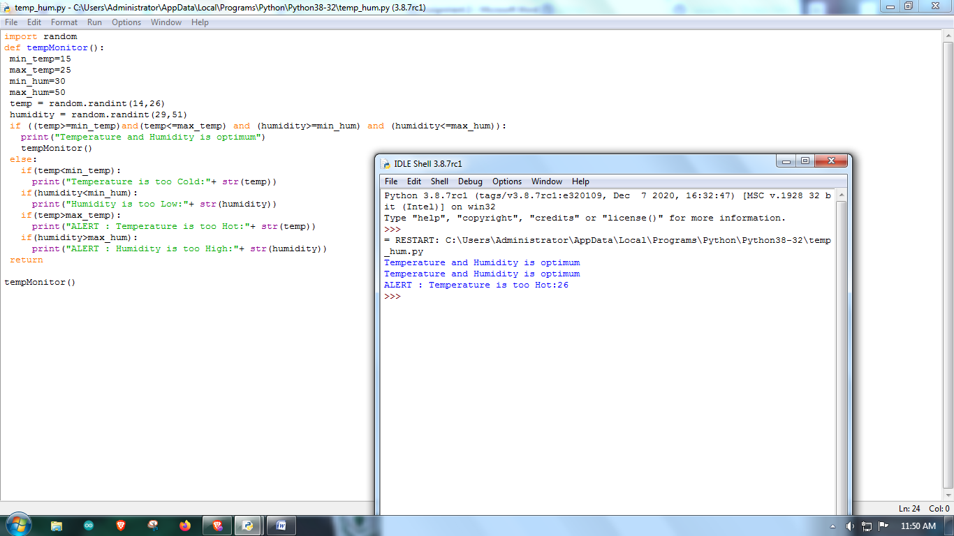

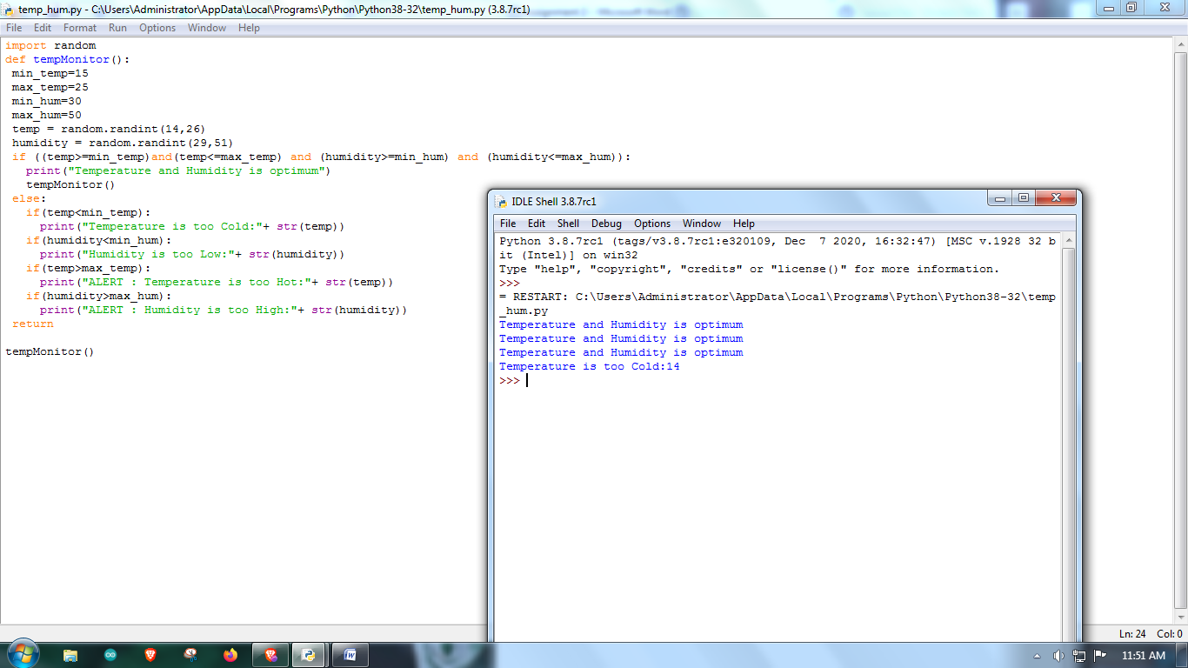

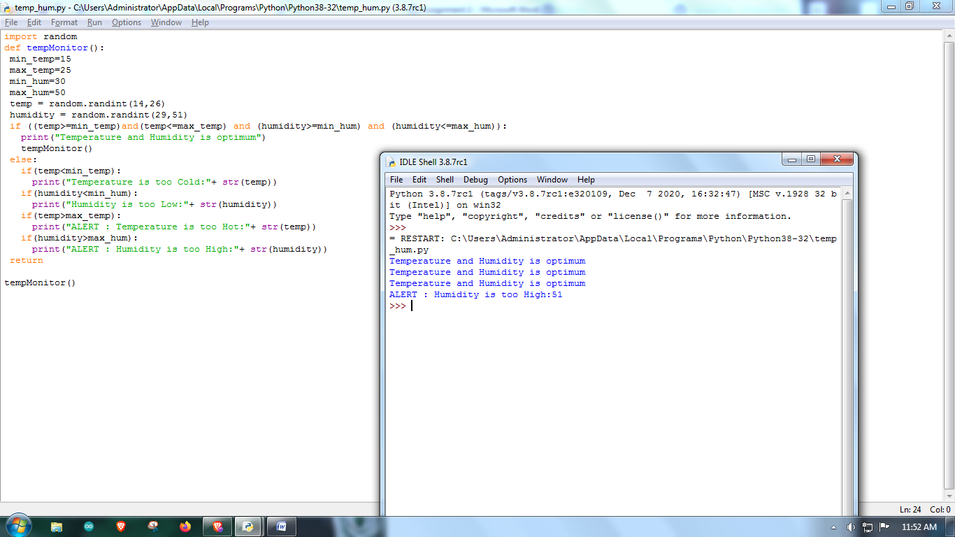

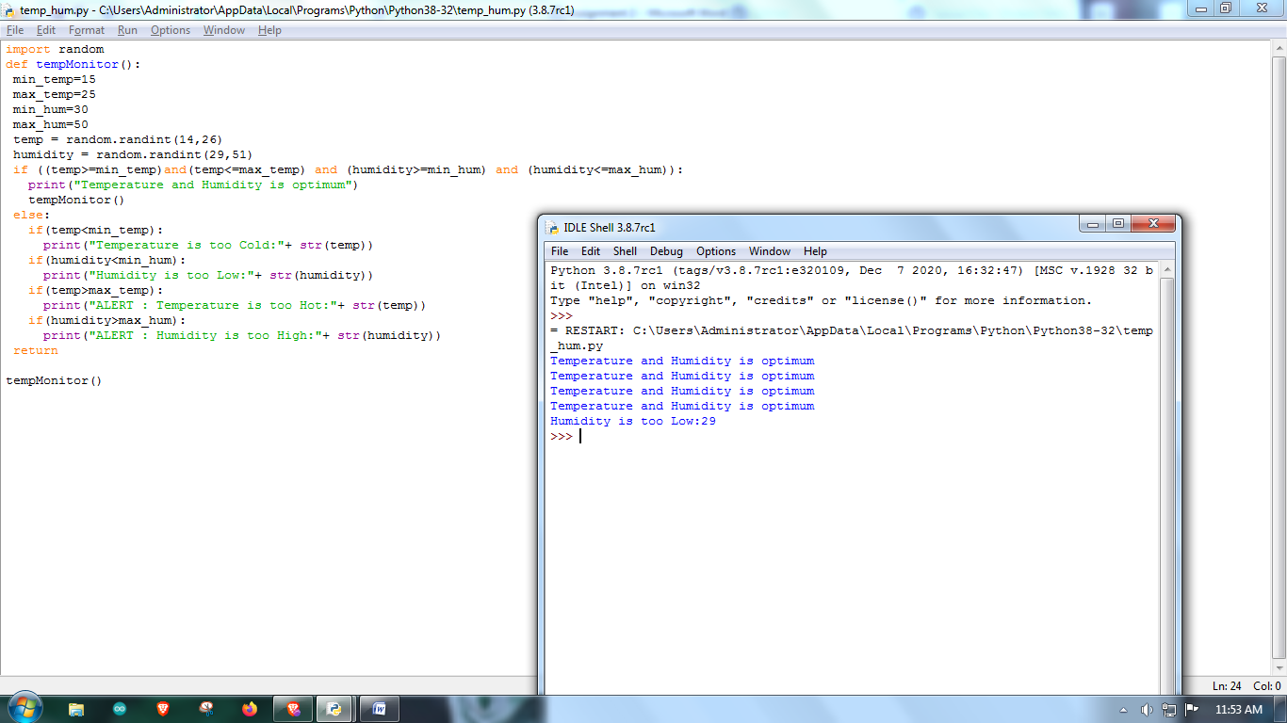

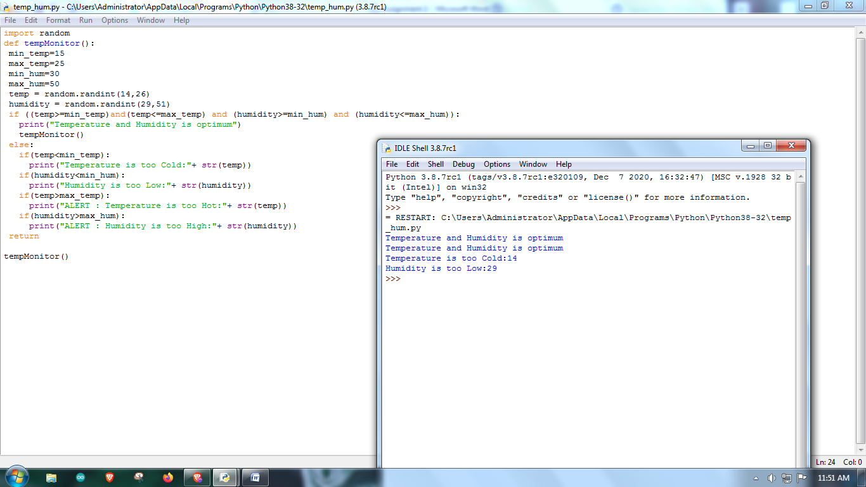

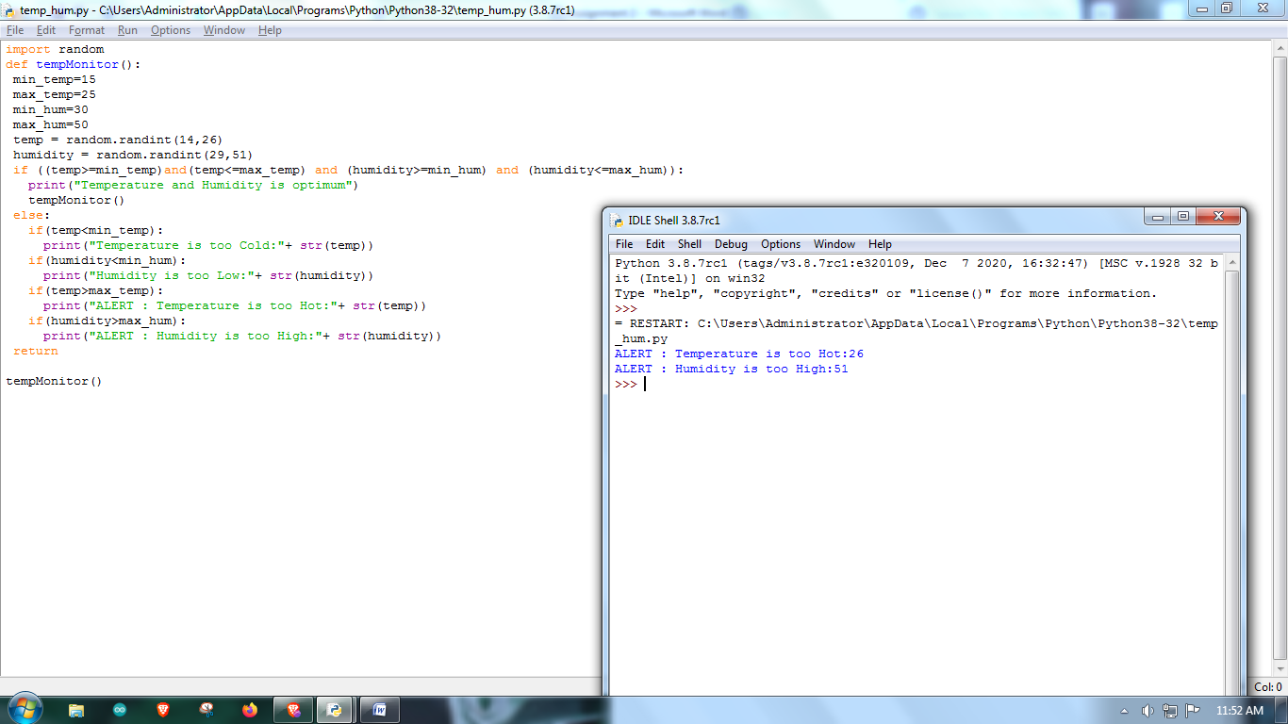

**By**

**Dinakar S**